How to Create Windows 7 Password Reset Disk in any Condition

Article Source:
http://recoverlostpassword.com/article/remove-windows-password.html

This article describes how to create and use a Windows 7 password reset disk for a computer before and after you forgot the password. You can use Windows 7 password reset CD to gain access to your computer.

Scenario 1: I don’t forget the password yet.

Windows 7 has its own backup feature, and you can proactively create a Windows 7 password reset disk before you forget it. With it, you can easily reset your Windows 7 password and get right into your PC.

Follow the easy steps below to create a password reset disk to your own Windows 7 account. Here’s how:
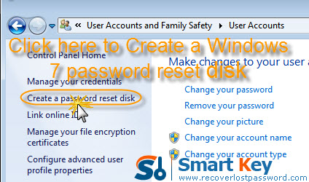
Note that this procedure requires one blank, formatted floppy disk.

- Click on “Start”->”Control”->”User Accounts and Family Safety”->”User Accounts”.
- In the task pane, click “Create a password reset disk”. The “Forgotten Password Wizard” appears.
- Click “Next”, and then choose the portable media drive.
- Click “Next”, and then enter your current password in the next box and click “Next”.
- Windows 7 begin to create the password reset disk on your chosen media. When the progress bar reaches 100% complete, click “Next” and then click “Finish”.
- Now you can remove your device and store the disk in a safe place. Once you forget the password in the future, you can take it out.

Follow the easy steps below to use a password reset disk to your own Windows 7 account. Here’s how:

- The created password disk can now be used during log-ins to reset the password. A reset password link appears on the account screen after an unsuccessful attempt to log in.
- Click on “Rest Password”, and the “Password Reset Wizard” dialog opens. Here you need to insert the reset disk to the PC.
- Follow the wizard to type a new password twice to make sure you type the correct password. You are suggested to create a new password hint, so that you can remember the password with it if you forget it.
- Windows switches to the Windows log-in screen again where you can use the new password to log in.

Scenario 2: I have already forgotten the password.

If you have already forgotten your Windows 7 password but don’t have a password reset disk at hand, you can choose another way to reset the password.

Here is how to create Windows 7 password reset CD/USB:
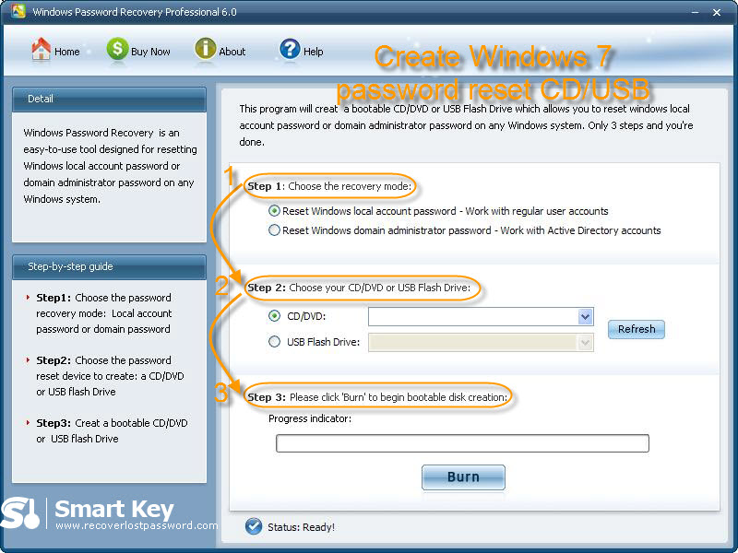
- This procedure needs a CD or USB flash drive. Insert your media device into another computer which can access to system as administrator.
- Launch Windows 7 password reset disk software. On the main interface, choose “reset Windows local account password”.
- Choose your target device, and click “Burn” to start Windows 7 password reset disk creation.

Here is how to reset Windows 7 password:

- With this Windows 7 Password Reset USB software, boot the computer that you want to reset the password for.
- Under Windows PE, you enter the main interface of this software. Choose your Windows system, and select the user account you need to reset password.
- Click “Reset”, and then “Yes” &“OK” sequentially to finish removing Windows 7 password.

Quite easy, isn’t it? After fully control system password reset, you will never worry about your bad memory.

